NAME: K HARISH ARJUN

**EMP ID: 289241**

**Beginner Project 2**

To-Do List App (Frontend)

OBJECTIVE: Build a basic To-Do list web application using HTML, CSS, JavaScript

SKILLS: Learn how to organize your code into commits and set up a GitHub repository

GITHUB Concepts: Regularly commit your progress, create branches for features and make pull requests.

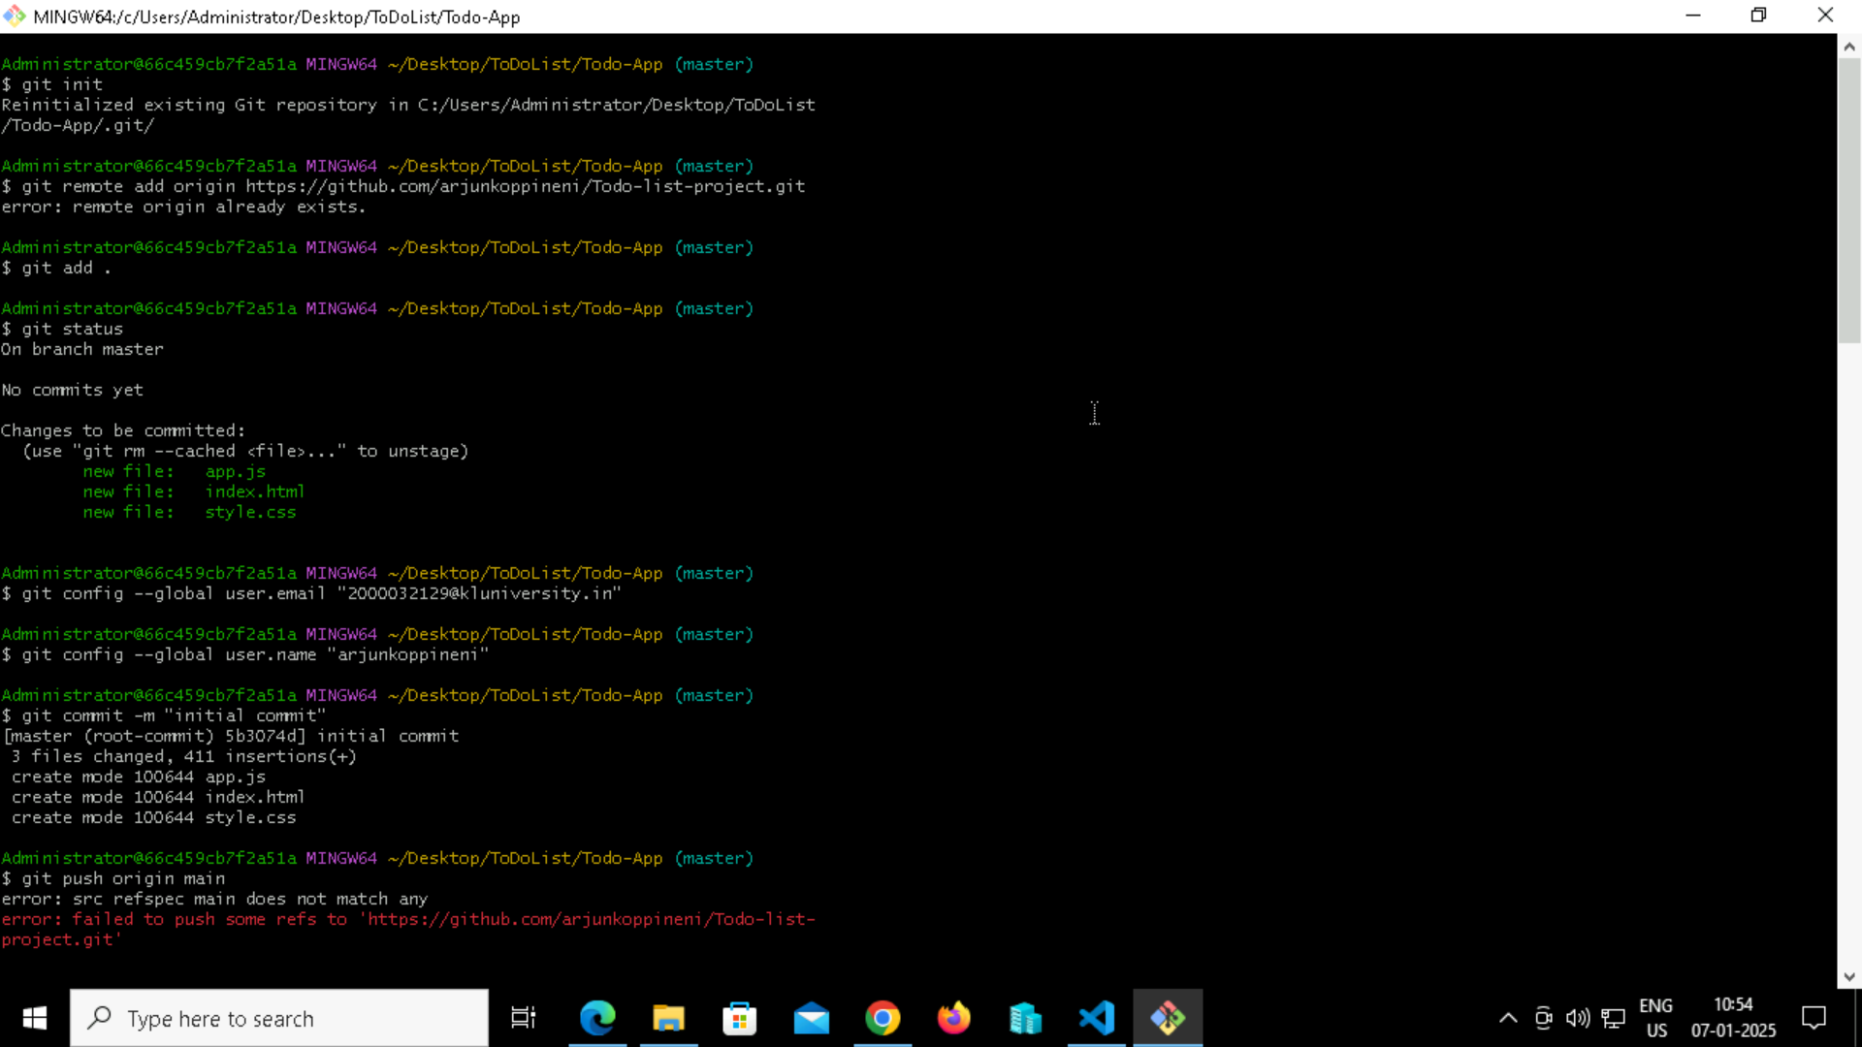

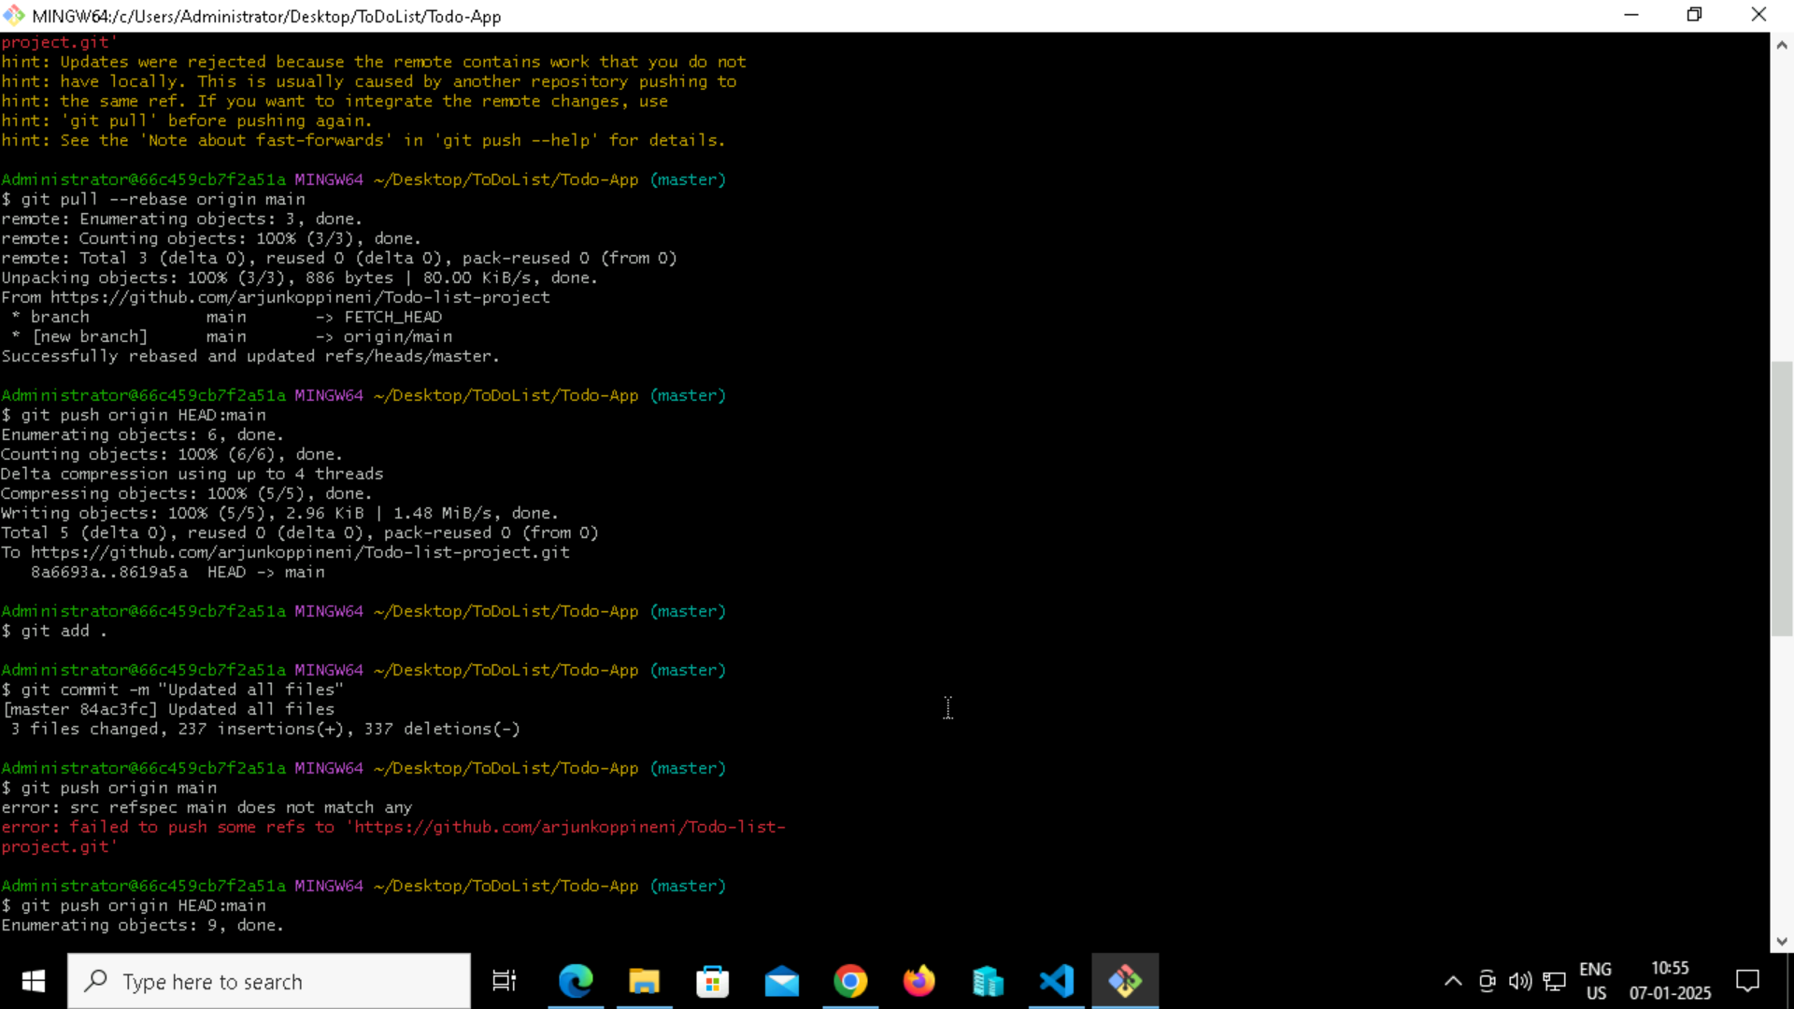

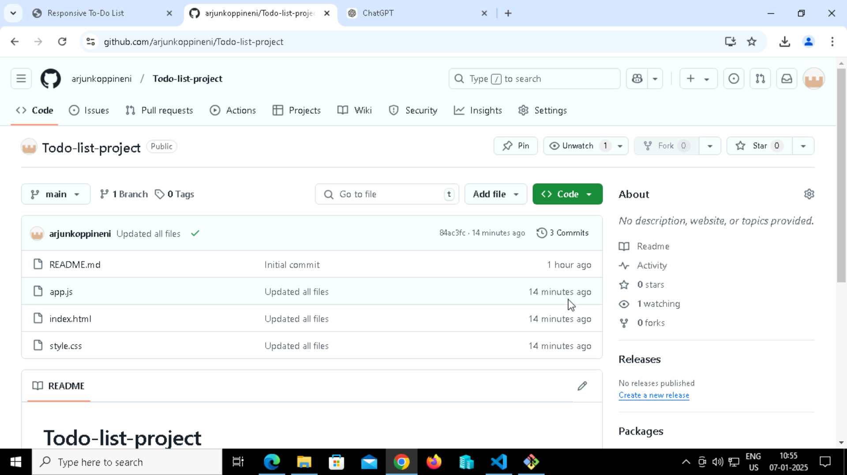

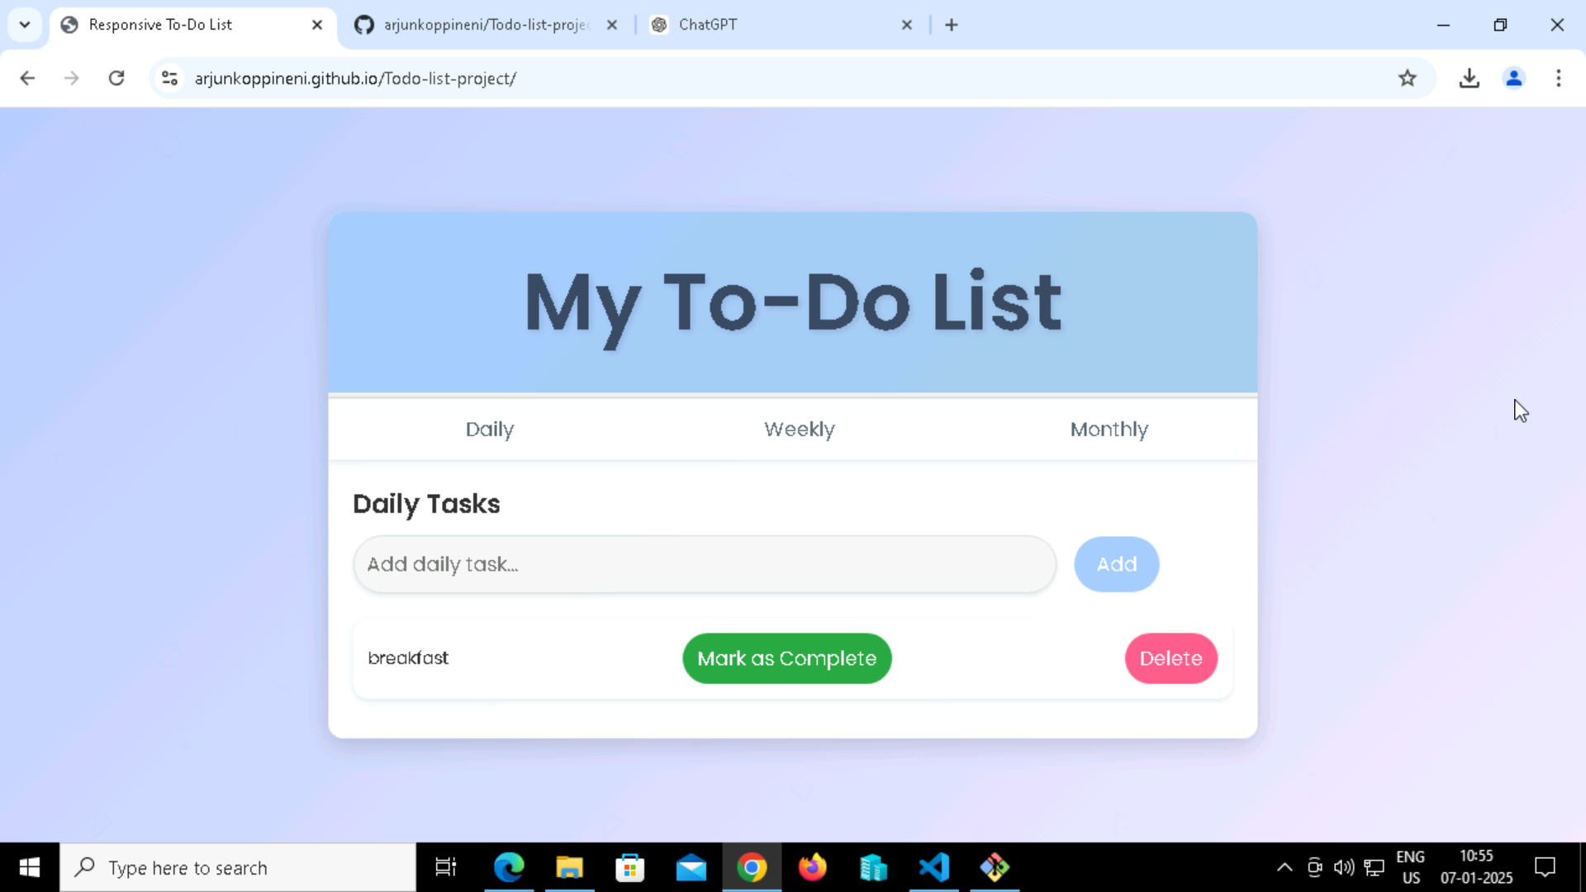

MAIN BRANCH:

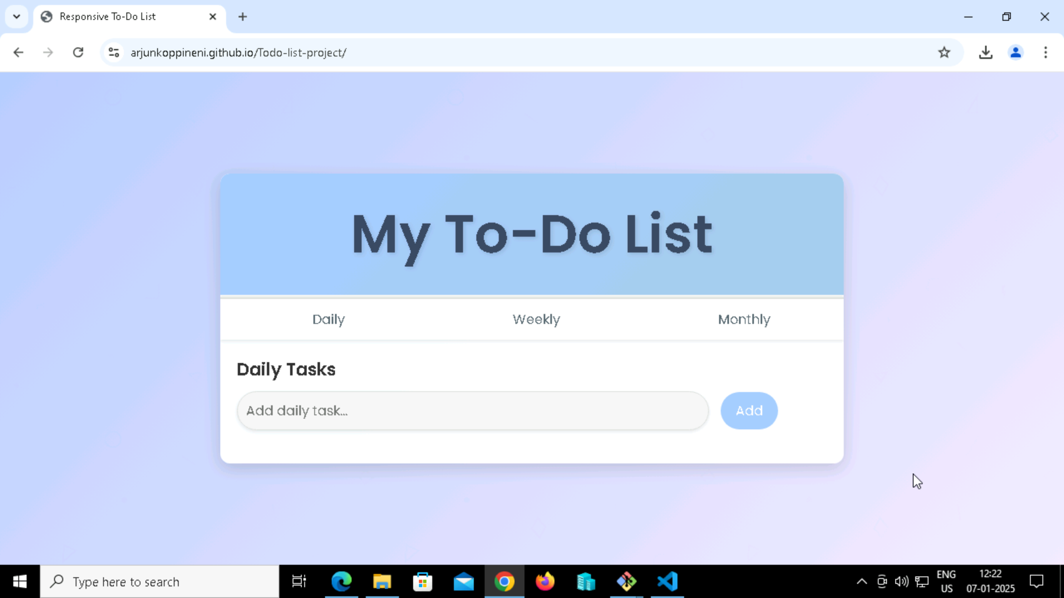

BRANCH1:

